## Homepage

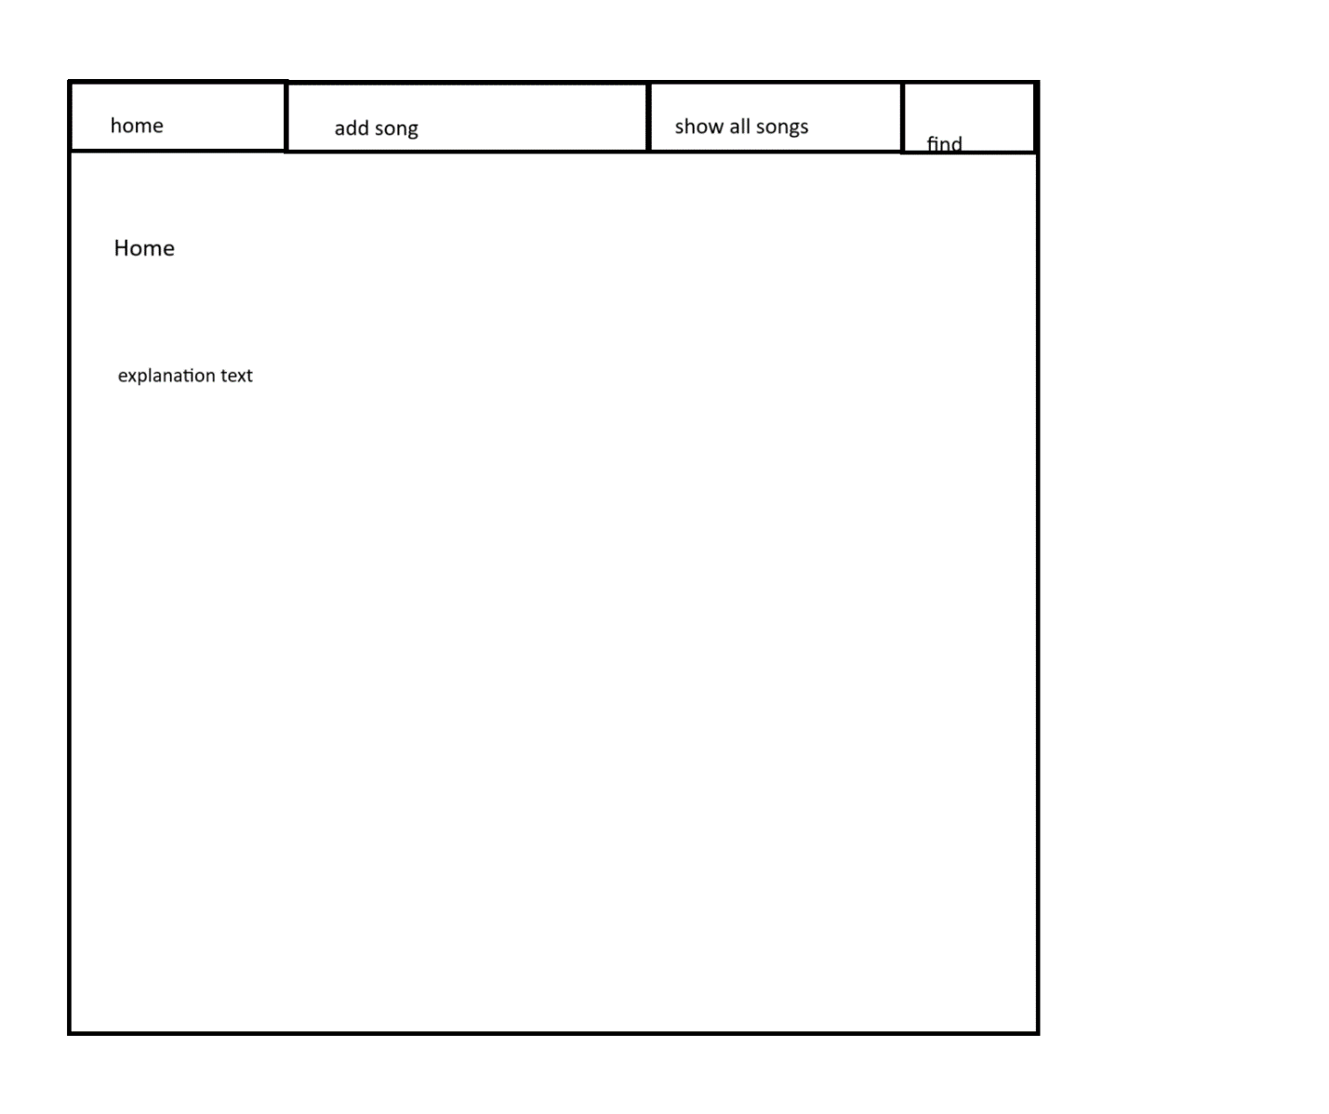

Describes the purpose of the site.

A site that will keep track of songs listened to and help find previously-listened-to related songs.

(I’m not sure that makes sense, so I’ll try to explain a bit more… basically, I listen to a lot of music on Youtube in other languages, and sometimes, I’ll remember a song I listened to, but because I don’t speak that language, all I can remember is the language its in, maybe the subject or thumbnail, and songs I listened to around the same time whose “related videos” section led me to that song. Sometimes I get lucky and find it again, but a lot of times, it’s gone forever.)

## Add Song Page

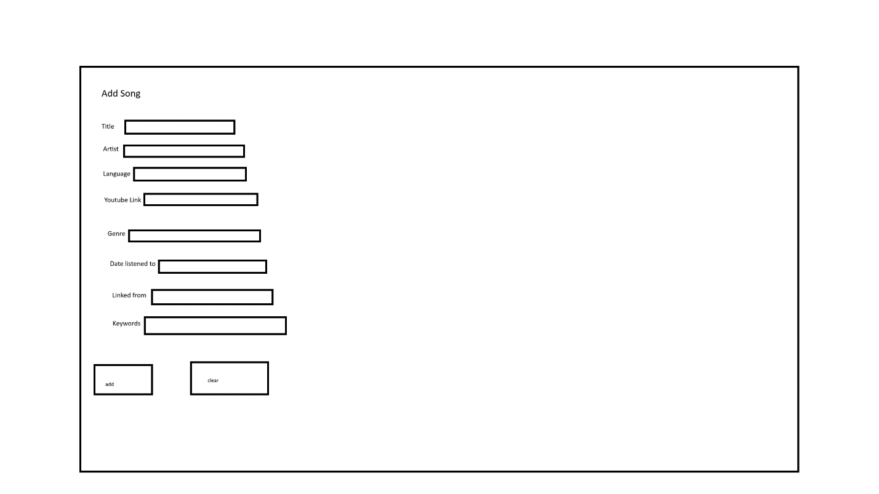

Youtube link is always required, due to the possibility of a song being taken down or different kinds of videos for the same song. The date is also required.

“Linked from” will need to be a Youtube link, and is required to be an already-entered link.

If the Youtube link is not found in a song that’s already on, the title, artist, and language will also be required.

## Show Songs Page

Lists all the songs, separated by language.

Clicking on the song will show all of the details that have been entered.

Will also show linked songs.

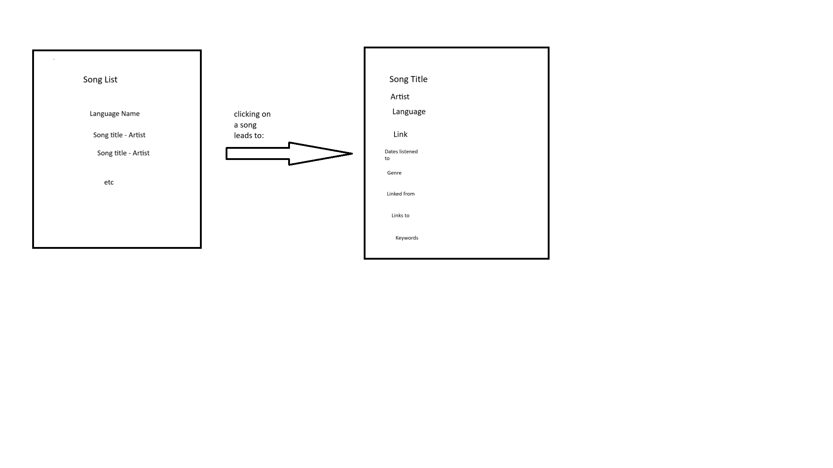

The bottom five properties will be lists. The linked songs will be links.

(I would also hope to be able to click on each date and see the list of songs listened to on that day, but I’m a bit worried about how slow the algorithm to do that would be.)

## Find Songs Page

Allows user to enter the language, related songs, and approximate date.

